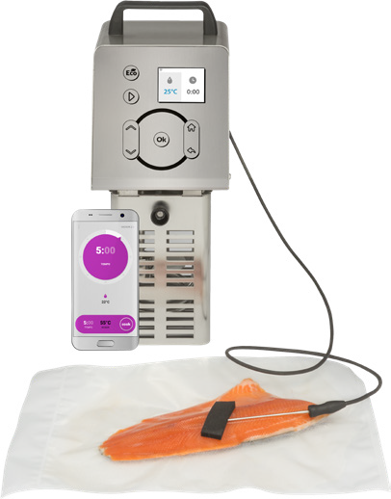

MANUAL FOR USE AND MAINTENANCE
PSV50 WIFI VACOOK
Thermal circulator for
SOUS VIDE
COOKING
REV N°1 2020

- PSV50 WIFI is not for use by children. Always have supervision when children are in proximity of the PSV50 WIFI.
- Please read all safety information and user instructions carefully prior to operating thermal circulator.
- All people responsible for assembly, installation, operation and repair must have read and understood the information contained in this manual.
- The User is responsible for understanding information in this manual. For any questions or concerns, please contact the manufacturer.
- This manual should be kept near the machine, so that it can be easily consulted by the User.
- The user should never tamper with the machine. In case of any problems found, please contact the Manufacturer.
- See Chapter “2. SAFETY” for all safety guidelines.
- The operation and safety of the unit will only be guaranteed if all the cleaning and maintenance instructions have been followed.
- The figures contained in this manual may differ from the machine.
- Install and use the thermal circulator only as shown in the
instructions.
- Periodically check the state of the power cord; a worn cable represents a serious electrical hazard. If the power cord is damaged, it must be replaced by the Manufacturer or other qualified personnel.

TABLE OF CONTENTS
INTRODUCTION 4
- MANUAL PURPOSE 4
- INFORMATION ON THE MACHINE 4
  - GENERAL PRECAUTIONS 5
  - SAFETY DEVICES INSTALLED ON THE MACHINE 6
  - DESCRIPTION OF THE MACHINE 6
    - Manufacturing features 6
  - INTENDED USE 7
  - FORBIDDEN USES 7
  - PERSONAL DATA 7
  - SAFETY GUARDS AND DEVICES 8
  - COMPONENTS OF THE MACHINE 8
- TECHNICAL DATA 9
  - OVERALL DIMENSIONS, WEIGHT, CHARACTERISTICS 9
- RECEIVING THE MACHINE 10
  - SHIPPING THE MACHINE 10
  - CHECKING THE PACKAGING UPON RECEIPT 10
  - DISPOSING THE PACKAGING 10
- INSTALLATION 10
  - PLACING THE MACHINE 10
  - ELECTRICAL CONNECTION 11
    - Electrical connection – 230V/50Hz 11
    - Electrical connection – 120V/60Hz 11
- MACHINE USE 12
  - CONTROLS 12
  - DESCRIPTION OF THE CONTROLS 12
    - Description of the symbols on the main screen 13
    - Functions available with the "Home" button 13
  - START PROGRAMMING THE MACHINE 15
    - Installation of the "Sous Vide Technology Wi-Fi" onto the APP 16
    - INSTANT COOK through the APP 18
    - INSTANT COOK from the thermal circulator 18
    - Cooking with programs 18
    - Starting cooking 18
    - Changing parameters during rapid cooking 19
    - End of cooking 19
    - Error messages 19
- CLEANING THE MACHINE 20
  - GENERAL INFORMATION 20
  - HEATER MAINTENANCE 20
- MACHINE MAINTENANCE 20
  - POWER CORD 20
- TROUBLESHOOTING 20
- SCRAPPING 21
  - DECOMMISSIONING 21
  - DISPOSAL 21
  - WEEE WASTE OF ELECTRICAL AND ELECTRONIC EQUIPMENT 21
- WIRING DIAGRAM FOR 230 VAC MACHINE 22
- WIRING DIAGRAM FOR 120 VAC MACHINE 23

INTRODUCTION
- This manual is to provide instructions, restrictions, and maintenance for the Sous Vide.
- A copy of this manual should be kept accessible to users and maintenance providers.

INFORMATION on your PSV50 WIFI
This device was expressly designed for vacuum cooking using only water as a cooking liquid. For safety reasons, at the end of each cooking cycle, the thermal circulator must be disconnected and immediately removed from the water for the following reasons:
- the electronic components of the machine cannot remain in hot water for long periods of time when the thermal circulator is OFF.
- Do not leave machine unattended while unit is running.
- if distilled water is not used, a long immersion time exposes the machine to the risk of limescale deposits on the heater. In the case of limescale deposits, it is advisable to perform a deep cleaning using a vinegar solution (1/10 vinegar to water solution). Without proper care and cleaning the machine will no longer hold precise temperatures and could overheat.

CAUTION! The warranty does not cover failures caused by improper use of the machine and damage caused by abandoning it in water when not in use

GENERAL PRECAUTIONS
    - The thermal circulator must be installed, used and cleaned only after carefully reading this manual. Pay close attention to the surroundings when using your Sous Vide.
    - Keep away from heated parts
    - Disconnect the machine from the power supply and allow to cool down prior to cleaning and maintenance
    - Always use caution when performing maintenance or cleaning of the machine and the guards are removed.
    - Periodically check the state of the power cord; a worn cable represents an electrical hazard. If the power cord is damaged, it must be replaced by the manufacturer or other qualified personnel.
    - Should the machine malfunction, it is recommended not to use it and to call the manufacturer’s service center.
    - Only an authorized service center should be used for repairs
    - Any attempt to disassemble, modify or generally tamper with any component of the machine by unauthorized personnel will result in voiding the warranty and relieving the manufacturer from liability.
    - The Manufacturer is not responsible in the following cases:
      - improper use or tampering with the machine by inadequately trained personnel;
      - failed or improper maintenance;
      - use of non-original and non-specific spare parts for the model;
      - total or partial failure to comply with the instructions in the manual;
      - machine surface treatment with unsuitable products.
    - Some parts of this product can become very hot and cause burns. Particular attention must be paid in the presence of children or vulnerable persons.
    - Install and use the thermal circulator only as shown in these instructions.
    - These instructions do not cover every possible situation that may arise. Always use common sense and prudence in installing, operating and storing the device.
    - It is forbidden to alter the characteristics of the machine in any way and to remove any fixed part.

SAFETY DEVICES INSTALLED ON THE MACHINE

The thermal circulator is provided with safety measures for electrical and mechanical protection both during operation, cleaning and maintenance. The safety devices against electrical and mechanical risks have been applied in compliance with the 2014/35/EU Low Voltage Directives (26 February 2014), Electromagnetic Compatibility 2014/30/EU (26 February 2014), to Machinery Directive 2006/42/EC (17 May 2006) and the standards CEI EN 603351-1 (Safety of household and similar electrical appliances) and CEI EN 60335-2-74 (Particular requirements for portable immersion heaters).
Furthermore, the thermal circulator also complies with the following standards:
Commercial Electric Cooking Appliances (UL 197:2010Ed.10+R:26Jan2018) Commercial Cooking Appliances (CSA C22.2#109:2017Ed.3)
Commercial Cooking, Rethermalization, And Powered Hot Food Holding and Transportation Equipment (NSF 4:2016)
However, there are "RESIDUAL RISKS" that cannot be totally eliminated; referred to in this manual in the form of "CAUTION!", they concern the danger of burns, electrocution, cutting or bruising deriving from the clumsy use of the machine, to the incorrect securing of the same to the tank, and during the machine cleaning operation.

MACHINE DESCRIPTION

The thermal circulator was designed and manufactured with the express purpose of guaranteeing:
- Sturdiness and stability of all its components;
- Excellent handling thanks to the handle that facilitates and makes the transport of the machine convenient;
- High precision thermoregulated heating;
- Circulating impeller to favor an excellent mixing of the water and, therefore, a constant temperature throughout the cooking tank;
In the event of an accident, no responsibility can be charged to the Manufacturer if the machine has been modified, tampered with, deprived of safety guards or used for purposes not specified by the Manufacturer.

Manufacturing features

The structure of the thermal circulator is manufactured entirely in AISI 304 stainless steel, which guarantees hygiene and unassailable from acids and salts, as well as excellent resistance to oxidation.
      - The heating element consists of a spiral armored heater, created specifically for immersion in water;
      - Upper handle for easy transport of the machine;
      - Protection device that turns off the machine if an overtemperature is detected;
      - Water level probe that blocks the machine in case of insufficient water.

INTENDED USE

The thermal circulator is designed for sous vide (vacuum) in water cooking applications.
Cooking must be carried out using an immersion tank designed for use, clean and suitably insulated and covered with specific insulating spheres. Improvised lids must not be applied as these could favor the concentration of water vapor in the vicinity of the machine with consequent damage.
This product was not designed for cooking food in ways other than vacuum cooking or for heating
liquids other than water.

FORBIDDEN USES
The machine must be used exclusively for the purposes intended by the Manufacturer, in particular:
    - Do not use the machine if it has not been correctly installed with all the guards intact and mounted to avoid the risk of severe personal injury;
    - Do not access the electrical components without having previously disconnected the machine
from the power supply line: there is a risk of electrocution;
    - Do not connect the machine to electrical outlet if it has not been firmly secured to the tank: there is a risk of electrocution;
    - Do not start the machine in failure;
    - Before using the machine, make sure that any condition that is dangerous for safety
has been properly eliminated. In the presence of any irregularity, stop the machine and inform the maintainers;
    - Do not allow unauthorized personnel to work on the machine;
    - Do not use the machine by connecting it to systems without grounding and without a differential switch (commonly called a "life saver");
    - Do not turn the machine upside down this could cause injury and/or damage to the heating element
    - Do not use the machine unless it is fastened to the edge of the tank using the provided
securing clamp.
Urgent treatment in the event of an accident caused by electricity requires, in the first instance, detaching the injured person from the conductor (as he/she is usually unconscious). This operation is dangerous. In this case the injured person is a conductor: touching him/her means being electrocuted.
It is therefore advisable to remove the plug directly from the power supply socket of the line, or if this is not possible, remove the victim using insulating materials (for example, sticks of wood or plastic, fabric, leather).
It is advisable to promptly let medical personnel intervene and hospitalize the patient in a
hospital environment.

PERSONAL DATA

An exact description of the "Model", the "Serial number" and the "Year of manufacture" of the machine will facilitate rapid and effective responses by the Service Center: it is recommended to indicate the model of the machine and the serial number each once you contact the Service Center.
This data can be read on the data plate on the back of the machine.

SAFETY GUARDS AND DEVICES

CAUTION! Before proceeding with the use of the machine, make sure that the safety devices are intact and correctly positioned. Check their presence and efficiency at the beginning of each work shift; otherwise, notify the maintainer and do not start the machine.

- Heater protection grid: it prevents contact with the heater and the impeller, thus avoiding the risk of serious injuries and burns for the operator.
- Automatic protection device in case of dry use: it stops the machine operation if the water level is lower than the minimum one allowed (75 mm from the upper edge of the immersion tank); in this case, an H2O error message will appear on the display (paragraph 6.3.8).
- Locking device: it stops the operation of the machine if the temperature probes detect a temperature difference greater than 15°C (59°F) or an absolute temperature higher than 130°C (266°F); in this case, a probe error message will appear on the display.
- Securing clamp: it must always be firmly secured to the machine body; if it is loose, it can compromise the positioning of the machine and, therefore, cause the thermal circulator to fall into the water with consequent risk of electric shock and machine failure.
- Fuse holders and fuses inserted and well tightened (9).

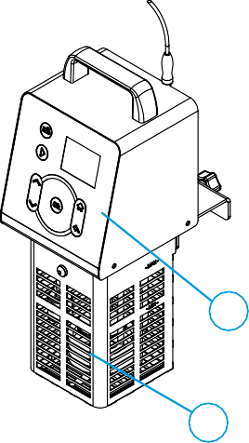
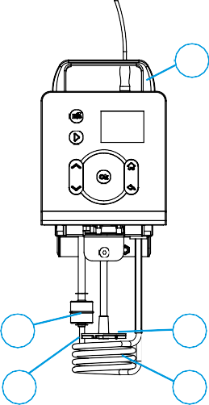
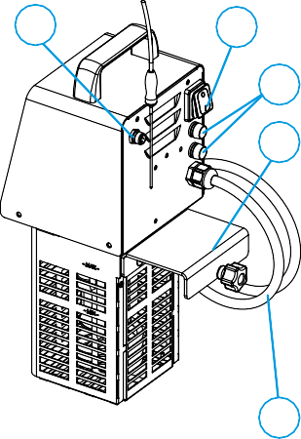
COMPONENTS OF THE MACHINE
1
2

7
4
6
5
3
12
11
9*

8
10

1 Front side / User interface 7 Handle
6
5
4
3
2
Water movement impeller
Water temperature probe
Water level sensor
Heater
Protection grid
12
11
10
9*
8
Socket for external temperature probe
Switch (ON/OFF)
Power cord
Fuses
Securing clamp
*The 120VAC version is equipped with one fuse

TECHNICAL DATA

3.1 OVERALL DIMENSIONS, WEIGHT, CHARACTERISTICS
Fig. n°2 - Dimensions and overall dimensions of the machine

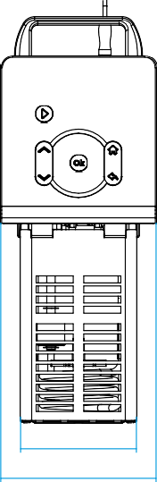
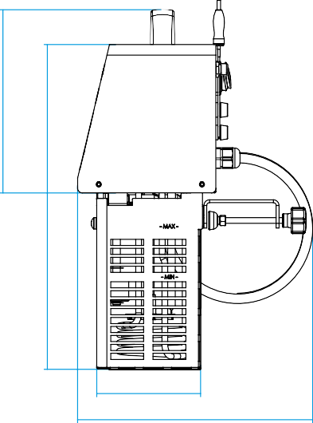
G
A
C
F *The 120VAC version is
equiped by one fuse

E

B
D

Model | M.U. | 230VAC version | 120VAC version
Max. absorbed power | W | 2.050 | 1.650
Power supply | Volt / Hertz | 220-240VAC / 50-60Hz | 110-135VAC / 50-60Hz
Temperature | °C / °F | 0 –95 / 32 – 203 | 0 – 95 / 32 – 203
Cooking time | h.m | 00.00 – 72.00 | 00.00 – 72.00
Delayed startup | h | 0 – 72 | 0 – 72
A x B | mm | 110 x 111 | 110 x 111
C x D | mm | 148 x 241 | 148 x 241
E / F / G | mm | 188 / 158 / 195 | 188 / 158 / 195
Net weight | kg | 4,5 | 4,5

CAUTION! THE ELECTRICAL CHARACTERISTICS FOR WHICH THE MACHINE IS MANUFACTURED ARE APPLIED ON THE BACK; BEFORE CARRYING OUT THE CONNECTION, SEE THE SECTION: 5 - INSTALLATION.

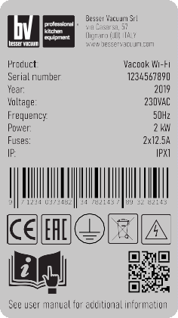
RECEIVING THE MACHINE

SHIPPING THE MACHINE

The machines leave our warehouses after being carefully packed. The packaging consists of:
    - external box in sturdy cardboard plus internal in-fill
    - machine
    - manual
    - core temperature probe
    - spheres
    - neoprene tape
    - 10 cooking bags 20x30 cm
Check the data and serial number on the machine plate correspond to the data on the delivery and accompanying documents.

CHECKING THE PACKAGING UPON RECEIPT

Upon receipt of the package containing the machine, carry out a careful inspection of the packaging to verify that it has not suffered serious damage during transport.
If the external inspection shows signs of mistreatment, bumps or falls, it is necessary to report the damage to the courier within three days from the date of delivery shown on the documents and draw up a precise report listing the visible damages suffered by the machine.

DISPOSING THE PACKAGING

The packaging components are products that can be assimilated to solid urban waste; therefore, they can be disposed of without difficulty. The materials used for packaging are recyclable. We therefore recommend storing them in the appropriate containers for separate collection. If the machine is installed in Countries where there are special regulations, dispose of the packaging in accordance with the regulations in force.

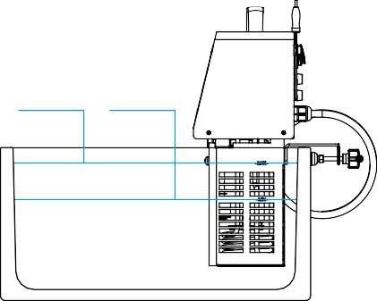
INSTALLATION
MAX MIN

PLACING THE MACHINE

Secure the thermal circulator at the edge of the cooking tank by means of the clamp on the back of the device. It is advisable to fill the tank
with preferably distilled water to preserve the machine from any limescale deposits that could irreparably damage the heater. During the tank filling phase, pay particular attention not to stay below the minimum water level required
to the operation of the machine and not to exceed the maximum level. The minimum (MIN) and maximum (MAX) indications are printed on the front side of the heater protection grid.

CAUTION: Take into account that the food inserted in the tank increases the water level. Make sure that the water does not exceed the maximum level! Inside the upper body of the machine there are the electrical and electronic parts that, in contact with water, could be irreparably damaged!

ELECTRICAL CONNECTION

Before inserting the plug into the socket, carefully check that the voltage of the power supply corresponds to the value in VAC shown on the machine plate and that the power socket and the power supply line are correctly sized with respect to the power of the device (also shown on the technical data plate in W). Make sure that the power supply line is equipped with a device that allows the disconnection of the thermal circulator from the building's electrical network, according to the current standards. It is mandatory that the power line is equipped with a differential protection device (commonly called "life saver").

Make sure that the switch and the socket are easily accessible during use of the device, so as to facilitate the machine disconnection operations in case of emergency.

Electrical connection – 230V/50Hz

The device is supplied with a power cord with a 3x1.5 mm² section for a length of 2.3 m and a SCHUKO plug (CEE7/7). Connect the machine to a 230 Volt 50 Hz network.

Electrical connection – 120V/60Hz

The device is supplied with a power cord with a 3x14AWG section for a length of 1.8 m and a NEMA 5-15P plug. Connect the machine to a 120 Volt 60Hz network.

MACHINE USE

CONTROLS
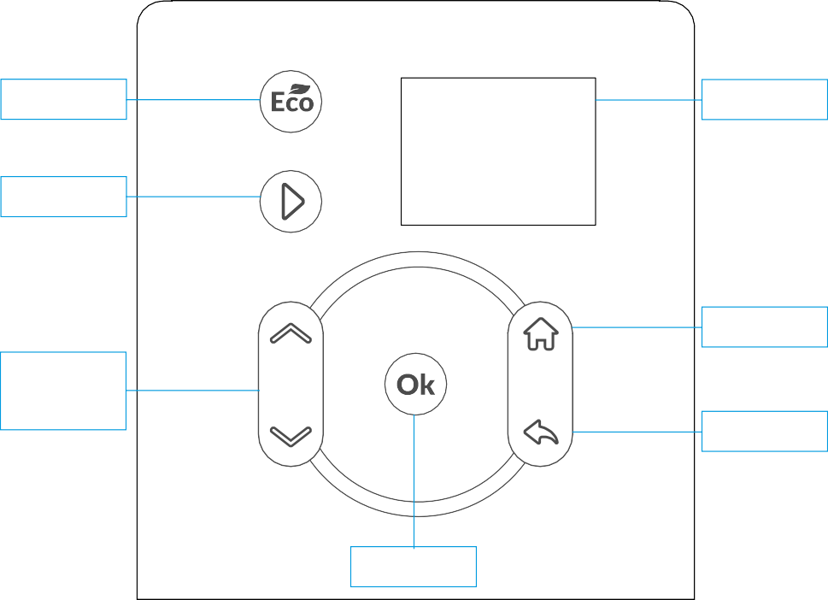
ECO
Display
Start
Home
Directional
Arrows
Back
Ok

DESCRIPTION OF THE CONTROLS

    - "Eco": Decreases consumption of electric power but increases the pre-heating time of the machine; it allows the use of the thermal circulator in conjunction with other household appliances.
•"Start": Starts the work cycle of the machine; press and hold for 3 seconds to stop the cooking cycle in progress and return to the main menu.
•"Directional arrows": Allow to manually set the cooking time and water temperature, thus increasing or decreasing to desired values and scroll through the "Home" menu.
•"Ok": Confirms the selection set on the display.
•"Home": Allows you to access to the "Programs", "Wi-Fi Connectivity" and "General Settings" sections of the machine (paragraph 6.2.2)
•"Back": Return to the screen prior to selection.

Description of the symbols on the main screen
1:00

60,0˚C
25,5 15,2
Wi-Fi connection ON
Desired cooking
time
Core probe temperature
(N/C = external probe
not connected)
Desired
water time
Current water temperature
Heating ON
Eco mode ON
On subsequent screens and during the cooking phases, some of the symbols shown above
may not be present.

Functions available with the "Home" button

Pressing the "Home" button accesses the following menu:
“PROGRAMS”: list of cooking programs previously stored through the APP. Each stored program can be renamed, modified and/or deleted at any time.
      - “Additional programs": additional cooking programs, which can be downloaded directly from the Sous Vide Technology application (Play store and Apple store). Once the desired program has been chosen through the "Directional Arrows", by pressing the "Ok" button you access the following sub-menu that allows you to set and/or modify the selected program:
        - “Start Cycle": pressing the "Ok" button immediately starts the selected cooking cycle.
        - "Delayed start": it allows you to manually program the delayed start of the cooking cycle. Pressing the "Ok" button accesses a stopwatch that can be set using the "Directional Arrows".
        - “Phases": by pressing the "Ok" button, you access the following sub-menu:
          - “Target": Choose between two temperature detection modes (detection of the temperature of the cooking water or detection of the temperature of the product by means of a core probe). Press the "Ok” button to access the two
temperature detection modes and use the "Directional Arrows" to select the desired option ("water" or "core") then press the "Ok" button to confirm the operation. To allow the correct detection of the temperature of the product by means of a core probe and the regular start of cooking operations, it is strictly necessary to connect the probe to the heat exchanger. In case of failed connection or damaged probe, an "Error" message will appear and cooking will not start.
          - "Temperature": Manually set the target temperature. By pressing the "Ok" button, modify and/or set the temperature parameters using the "Directional Arrows", then confirm the desired operations using the "Ok" button.
          - "Delta T": Function visible only when the temperature of the product is measured using a core probe. Defines the difference between the temperature of the cooking water and the core probe. Through the "Directional Arrows", you can select the desired temperature delta then you can press the "Ok" button to confirm the selection.
The lower the selected delta the longer the time required for the core temperature to reach the requested level (Delta min. = 2 | Delta max. = 20 | default = 5).

          - “Time": Manually set the desired cooking time. By pressing the "Ok" button, set and/or modify the time parameters using the "Directional Arrows", confirm the desired operations using the "Ok" button.
There are two specific cases:
Cooking with the core probe: the time runs from the time when the probe reaches the
previously set core temperature.
Cooking without core probe: the time runs from when the water temperature reaches the previously set temperature; an alert will indicate when the unit has reached temp to facilitate the operations of inserting the food in the tank.

“WI-FI CONNECTIVITY”: Information relating to Wi-Fi connection and allows access to the following sub-menu:
      - "Reset AP": Reset the Access Point function of the machine and return to the factory condition. Press the "Ok" button to access the selection menu and use the "Directional Arrows" keys to select to proceed with the reset.
      - "Status": Information on the status of the Wi-Fi connection.
        - "Connected": Indicates the machine is connected to Wi-Fi (YES/NO)
        - "Connection type": Type of existing connection (AP/ROUTER)
        - "MAC": Media Access Control address of the machine
        - "IP": IP address of connection to the local network
        - "Subnet": Subnet address used by the local network

“SETTINGS”: General information concerning the machine and access to sub-menu:
      - "Language": Choose the language in which the device is used; press the "Ok" button and select the desired language using the "Directional Arrows", press "Ok" to confirm the selected language.
      - "Unit of measurement": Unit of measurement for temperatures (°C/°F). Press the "Ok" button and select the desired unit of measurement using the "Directional Arrows", press "Ok" to confirm.
      - "H2O probe calibration": Introduce or eliminate any offset between the cooking water temperature and external temperature probe. Press "Ok" to access the menu for selecting the desired temperature, select desired offset using the "Directional Arrows". The temperature at the core and cooking water detected by the machine are displayed in the upper right corner.
      - "Core probe calibration": Introduce or eliminate any offset between the temperature probe at core and external temperature probe. Press "Ok" to access menu for selecting the desired temperature, then select desired offset using the "Directional Arrows".
      - "Sound": Activate or deactivate the alert sounds of the device. To change the setting, press "Ok" and use the "Directional Arrows" buttons to "Activate" or "Deactivate”.
      - "Timer type": Select 2 different modes of cook time scrolling.
        - Incremental: View the time already elapsed from the beginning of the current
program.
        - Decremental: Displays the remaining time to completion of the current program.

To change the setting, press "Ok" and use the "Directional Arrows" to choose timer to set.
      - "Overtemperature Alert": Manually set the percentage of water temperature above which an overtemperature warning is activated. In the event of overtemperature detected, a message is displayed that allows you to choose whether to continue cooking or to leave the program in use. For example: with a set temperature of 55°C and a Max delta T (water temperature) of 10%, cooking starts directly up to 60.5°C; the overheating warning message will be displayed above 60.5°C.
      - "Device Info": View the technical data (the firmware versions of the electronic boards, the serial number of the device, the number of start-ups and number of hours of start-up since the first).
      - "Contacts": Contact the Manufacturer or Distributor indicated in the User manual.
      - "Restore": Restore the machine to factory conditions. Press "Ok" and select "YES/NO" using "Directional Arrows", press "Ok" to confirm selection.

START PROGRAMMING THE MACHINE

- Fill the cook tank with distilled water to preserve the thermal circulator from any scale deposits that could irreparably damage the heater. When filling the tank, fill to the minimum level ("MIN") of water required for the machine to operate, do not to exceed the maximum level ("MAX", paragraph 4.1).
- Make sure that the thermal circulator is plugged in, then secure to the tank using the special clamp system (paragraph 1.8).
- Plug the unit in, making sure that the power cord does not come into contact with heat sources, water, oils or metal parts that may damage it.
- Turn on the power switch (see paragraph 1.8, button 11 located on the back of the machine; a screen with a logo will appear first and for the first 10 start-ups, "Wi-Fi Configuration" to be made through the APP will appear. After the first 10 start-ups, only the following message will be displayed:

CAUTION! For the correct sanitization and preservation of food, we recommend cooking according to the times and temperatures suggested by the HACCP protocol. Privacy information available from the Sous Vide Technology Wi-Fi APP.

- The water temperature is set by default at 55°C and it will always be the user’s responsibility to select temperatures and times that guarantee the health of cooked food.

Installing the Sous Vide Technology Wi-Fi APP

Wi-Fi

The "Sous Vide Technology Wi-Fi" APP is available for download on the "Google Play™" stores for mobile devices with the Android™ operating system (version 5 and above) and on the "APP Store" for mobile devices with an operating system "IOS"™ (version 10 and above). Below is the icon that identifies the APP on the two stores:

Download and install the APP as required by your device, proceed with the registration on the cloud "Sous Vide Technology Wi-Fi". If the unit is not registered, the functionality of the APP will be limited.
Proceed with the following steps:
      - Switch on the thermal circulator, wait for the main screen to appear.
      - Access "Settings" menu of your smartphone, select "Wi-Fi" then select and connect to the "SVtech nnnn" WiFi network that will appear in the list of available networks (i.e. with iOS, select "Settings, Wi-Fi, SVtech 0001”).
      - Activate the APP Sous Vide Technology Wi-Fi, from the Instant Cook screen select, "Select Device" function located at the top right and select the device (i.e.: SVtech 0001).

CAUTION! Updates take approximately ten minutes, it is recommended to run only when there is no need for immediate use of the thermal circulator.
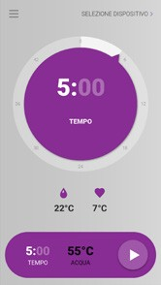
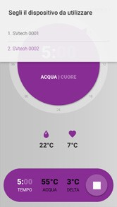
FIG 1 FIG 2
      - It is possible to start the synchronization of programs from the mobile device to the thermal circulator to allow new programs to be entered and/or updated on the APP even without the availability of the thermal circulator. Wait for the end of the synchronization of the programs or proceed without synchronization if this is not necessary.

      - Select the drop-down menu at the top left for Features:
        - “INSTANT COOK": Set the time and temperature parameters directly from
the APP.
          - To select the cooking time, select the digits in the center to change the hours and/or minutes, turn the arrow on the selection circle to set the desired value.
          - To select the "Temperature" of the water, select the digits in the center of the circle to change the degrees, turn the arrow on the selection circle to set the desired value. For the setting of tenths of a degree, set the degrees, touch the decimal position to increase it by 0.1°C for each touch. Select PLAY symbol (FIG. 1) to start cooking, then proceed as described in the paragraph 6.3.5 below.
          - To stop cooking, press the Stop button (square symbol, FIG. 2).
        - “PROGRAMS": Create new cooking programs or modify existing.
          - Delay the starting time by a maximum of 72 hours.
        - “GUIDED COOKING": Recommended cooking parameters for most foods. Choose type of food, desired cut, degree of cooking (i.e. Meat, Pork, Fillet; rare, medium, well done) and initial temperature of the same (fridge/freezer). Press "Play" button to start cooking.
        - “RECIPES": Includes a series of recipes included in the APP. List of ingredients to be used and steps to produce complex and elaborated dishes easily and quickly.
        - “TRACKING": Parameters of the cooking performed.
        - “WIFI": Connect the thermal circulator to access remotely. To allow a functional connection, follow the recommended steps:
- from the smartphone: "Settings", select "Wi-Fi", activate "Wi-Fi" option and connect to the available network. Once connected to Wi-Fi network, access the "Sous Vide Technology Wi-Fi" APP.
- "Sous Vide Technology Wi-Fi” APP: select "Wi-Fi", enter name and password. The connection of the thermal circulator will be retained. Allowing total monitoring of the
cooking in progress.

CAUTION! For safety reasons, the machine is switched on subject to the manual operations of its User, therefore, it will not be possible to turn on the Wi-Fi thermal circulator remotely or to start cooking food operations.

        - “ACCOUNT": Log in and log out to choose between °C or °F, view "OWNER" and "SHARED" modes. Owner allows the user to name the machine using the "pencil" symbol, share the machine with other Users and unlink the unit from the APP. Users can unlink the unit from the APP.

CAUTION! The heater and the cooking liquid could reach high temperatures: danger of burns!

INSTANT COOK through the APP

- Connect to the "Sous Vide Technology Wi-Fi" APP
  - Connect to the selected Wi-Fi network. Signal will show when connected.
- Follow the instructions for "Sous Vide Technology Wi-Fi" APP to start cooking
the selected product.

INSTANT COOK from the thermal circulator

To operate the cooking processes directly from the thermal circulator:
- Access the "Sous Vide Technology Wi-Fi" APP, select food type, view the recommended time and temperature parameters.
- Turn on the thermal circulator, set time and temperature parameters recommended using the "Directional arrows". At each touch, the parameters vary by a tenth; press and hold the arrow to scroll more quickly. “Ok” to confirm.
- Press the "Start" button.

CAUTION: The "flame" symbol indicates that the heater is heating the water. During the pre- heating phase, this symbol will always be ON, during the cooking phase, the symbol will continue to flash intermittently to report that the heater is keeping the temperature constant.

Cooking with programs

The programs can be created using the APP and can, consist of one or more cooking phases alternating with pauses with the heater switched off. Once created, new programs can be downloaded from the APP to the device. For each Wi-Fi connection between the smartphone and the machine, the User will be asked if he/she wants to download the programs on the APP to the machine. At this point, the User can select the desired program by pressing the "Home", "Programs", "My program" buttons. Pressing the "Start cycle" button followed by "Ok" then immediately starts the selected cooking cycle. You can start cooking.

CAUTION: The machine must be firmly secured to the edge of the cooking tank BEFORE connecting the plug the power supply; see paragraph "5.1 Placing the machine". If the upper body of the machine gets wet, DO NOT INSERT THE PLUG TO THE POWER SUPPLY and contact the Service Center.

Starting cooking
0:12

45,0˚C 55,0˚C 80,0˚C

- Once cooking is started, the heater of the machine starts to heat the water until it reaches the selected temperature.
- The water preheating cycle ends when reaching the
set temperature.
- The alert will sound when the set temperature is reached

- The alert has a duration of 1 minute, at the end of which the cooking process is automatically started. You can interrupt the acoustic signal and immediately start the cooking phase by pressing the "Start" button.

CAUTION: For the correct sanitization and preservation of food, we recommend cooking according to the times and temperatures suggested by the HACCP protocol.

Changing parameters during rapid cooking

During the cooking phase, you can modify the "time" and/or "temperature" parameters by pressing the central "Ok" button to return to the main menu. To confirm the changes made, press the "Start" button; otherwise, the machine will complete the cooking phase with the initial parameters.

End of cooking

At the end of the cooking phase, the machine releases an alert signal, lasting one minute. To interrupt the cooking cycle, press the "Ok" button. If the button is not pressed within one minute, the machine will start a cooling cycle that can be distinguished in two cases depending on the temperature:
- Temperatures greater than or equal to 54°C (129.2°F): in this case, the machine will continue to recirculate the cooking water, thus activating the heater only to maintain the water temperature above the safety limits of the healthiness of the food.
- Temperatures lower than 54°C (129.2°F): in this case, the machine will continue to recirculate the cooking water, without further temperature input.
It is the user’s responsibility to manage the food left in the water after the alert signal. It is advisable to remove the food from the water after cooking. The time elapsed after the cooking cycle is complete will appear on the display. To stop this state of temperature maintenance, the "Start" button must be pressed for 3 seconds to stop the unit and return to initial start-up conditions.

CAUTIONS! The heater and cooking liquid could reach high temperatures: danger of burns!

Error messages
ERRORE H2O

Aggiungere acqua

The error messages will appear in screens with a red background and corrective action to take. The following is an example of the error message that will be displayed in case of insufficient cooking water level.

Add water and the error will disappear while the machine will resume the cooking cycle in progress.
CAUTION: At the end of cooking, remove the plug from the socket and the heat exchanger, holding it by the securing handle and paying attention to the heated elements. Do not leave the heat exchanger turned off in hot cooking water as it would damage the thermal circulator. 19

- MACHINE CLEANING
CAUTION! Before performing any cleaning operation, disconnect the power plug from the
power source to completely isolate the machine from the rest of the system. Make sure the machine is cooled down completely.

GENERAL INFORMATION
    - The machine must be cleaned only when it is at room temperature. For cleaning, use a damp, soft cloth with neutral detergent. Do not use abrasive, corrosive or solvent cleaners.
    - Do not use water cleaners, pressure water jets or tools that could damage the surface of the machine or wet its internal components. Do not place any components in the dishwasher.
    - Never immerse the upper part of the machine in water.
    - In the event that water should enter the upper part of the machine (3cm above the "MAX" level), immediately unplug the power supply and allow the thermal circulator to dry for at least 24 hours prior to using again.

HEATER MAINTENANCE

To preserve the heater and all the parts that are immersed in the tank from limescale, it is advisable to add vinegar in the tank with distilled water, in quantities of 1 part in 100, at each work cycle.
If you want to clean the thermal circulator thoroughly from limestone residues, add 1l of vinegar every 10l in water and set the temperature to 35°C for 1 hour; water circulation will help clean and maintain the heater.

MACHINE MAINTENANCE

CAUTION! Before performing any cleaning operation, disconnect the power plug from the power supply to completely isolate the machine from the rest of the system. Make sure the machine is cold.

8.1 POWER CORD

Periodically check the state of wear of the cord and, if it is damaged, call the "SERVICE CENTER" for replacement if necessary.

TROUBLESHOOTING

THE MACHINE DOES NOT TURN ON:
- Check that the socket where the machine is connected is powered; this is possible by connecting another electrical device to this socket. If so, go to step 2
- Check that the power cord is properly connected to the power outlet. If it is connected correctly, go to step 3
- Check the position of the switch (ON/OFF) (11) on the back of the machine. If the machine does not switch on even with this operation, call for technical Service Center.

WATER LEVEL ERROR:
1. Check that the water level is correct (between the MIN. and MAX. values); otherwise, restore
the level correctly.

TEMPERATURE ERROR DETECTED COMPARED TO THAT SET:
- Check that the machine is not set on the wrong temperature scale (°C or °F).
- On the Probe settings-Calibration function, check that a value very different from 0 has not
been set by mistake.

THE MACHINE CANNOT BE REACHED BY THE SMARTPHONE:
1. Check the smart device to ensure the Wi-Fi option is ON. follow the connection instructions between the two devices.

DISMANTLING

DECOMMISSIONING

If for some reason you decide to decommission the machine, make sure it is unusable for any person, so disconnect the power cord and cut the electrical connections.

DISPOSAL

Once decommissioned, the machine can be disposed of by any company in charge of this service. For the scrapping of the thermal circulator, follow the regulations in force for waste disposal and management.

WEEE WASTE OF ELECTRICAL AND ELECTRONIC EQUIPMENT

Pursuant to Article 26 of Legislative Decree No. 41 of 14 March 2014, "Implementation of Directive 2012/19/EU, on waste electrical and electronic equipment (WEEE)", the symbol of the crossed out letter on the equipment or on its packaging indicates that the product at the end of its useful life must be collected separately from other waste. The separate collection of this equipment at the end of its life is organized and managed by the Manufacturer. The User who wishes to dispose of this equipment must therefore contact the Manufacturer and follow the system it has adopted to allow separate collection of the equipment at the end of its life.
The adequate separate collection for the subsequent start-up of the decommissioned equipment for environmentally compatible recycling, treatment and disposal contributes to avoiding possible negative effects on the environment and favors the reuse and/or recycling of the materials of which it is composed. Illegal disposal of the product by the owner involves the application of administrative sanctions provided by law.

WIRING DIAGRAM FOR 230 VAC

POWER SUPPLY
220-240VAC - 50/60Hz

G N L

FUSES 2x12,5A

30W SWITCHING POWER SUPPLY
OR +

100-240VAC

MAIN SWITCH

EMI FILTER

L
BK 12VDC
-
50/60 Hz

BULB THERMOSTAT 105 °C
WATER HEATING ELEMENT 230VAC 2000W

BK
WH RD

N L N
+ -
IN

L

OUT

N L

LOAD

ELECTRONIC BOARD

M

WATER CIRCULATOR BRUSHLESS MOTOR 20V

INTERNAL EXTERNAL PROBE PROBE
WH RD RD WH RD RD

PT100 TEMPERATURE SENSORS
WATER
LEVEL FLOATING SWITCH

USER INTERFACE

WIRING DIAGRAM FOR 120 VAC

POWER SUPPLY
110-135VAC - 50/60Hz

G N L

FUSE 1x15A

30W SWITCHING POWER SUPPLY
OR +

100-240VAC

MAIN SWITCH

EMI FILTER

L
BK 12VDC
-
50/60 Hz

BULB THERMOSTAT 105 °C
WATER HEATING ELEMENT 120VAC 1600W

BK
WH RD

N L N
+ -
IN

L

OUT

N L

LOAD

ELECTRONIC BOARD

M

WATER CIRCULATOR BRUSHLESS MOTOR 20V

INTERNAL EXTERNAL PROBE PROBE
WH RD RD WH RD RD

PT100 TEMPERATURE SENSORS
WATER
LEVEL FLOATING SWITCH

USER INTERFACE

Besser Vacuum Srl www.besservacuum.com info@besservacuum.com

